Tableau Assignment

1. What is the percent of total Sales for the ‘Home Office’ Customer Segment in July of 2012?

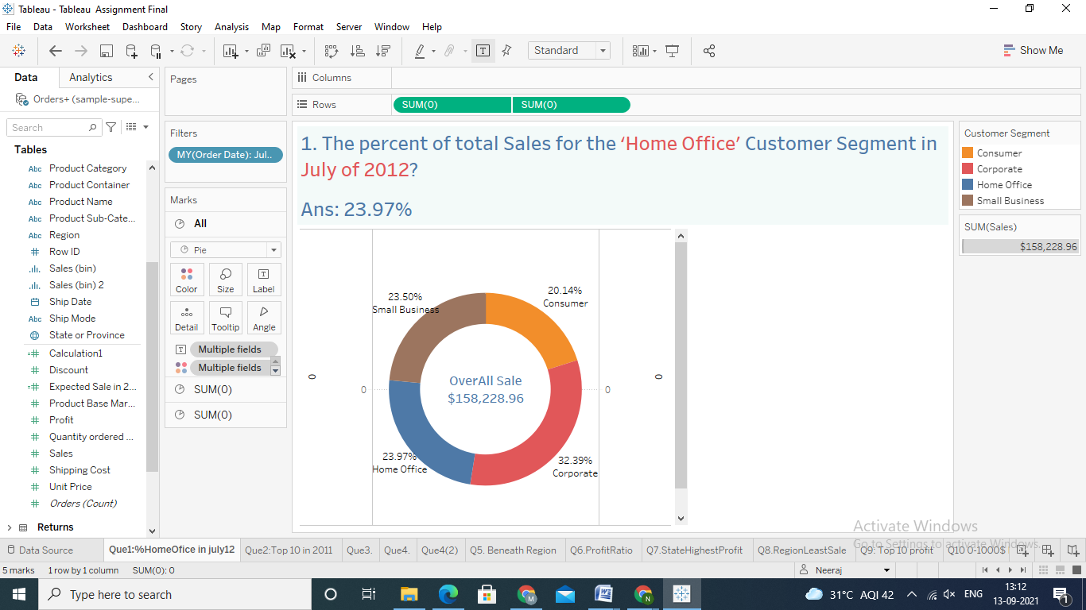

1. Find the top 10 Product Names by Sales within each region. Which product is ranked #2 in both the Central & West regions in 2011?

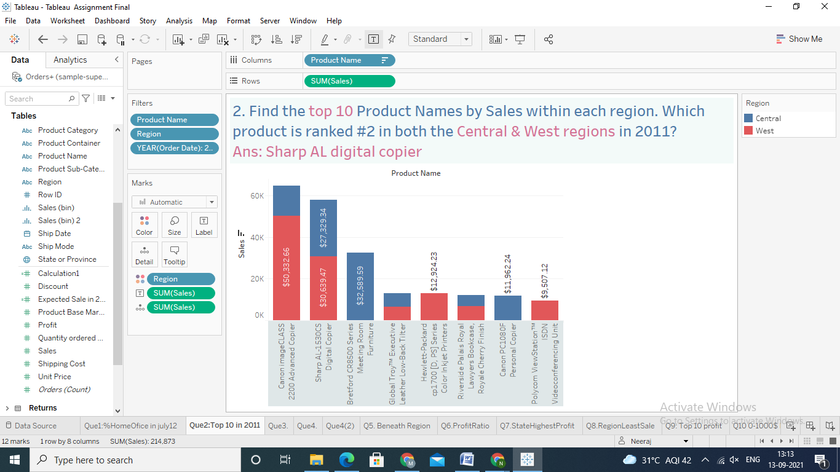

3. In the Technology Product Category, which unprofitable state is surrounded by only profitable

states?

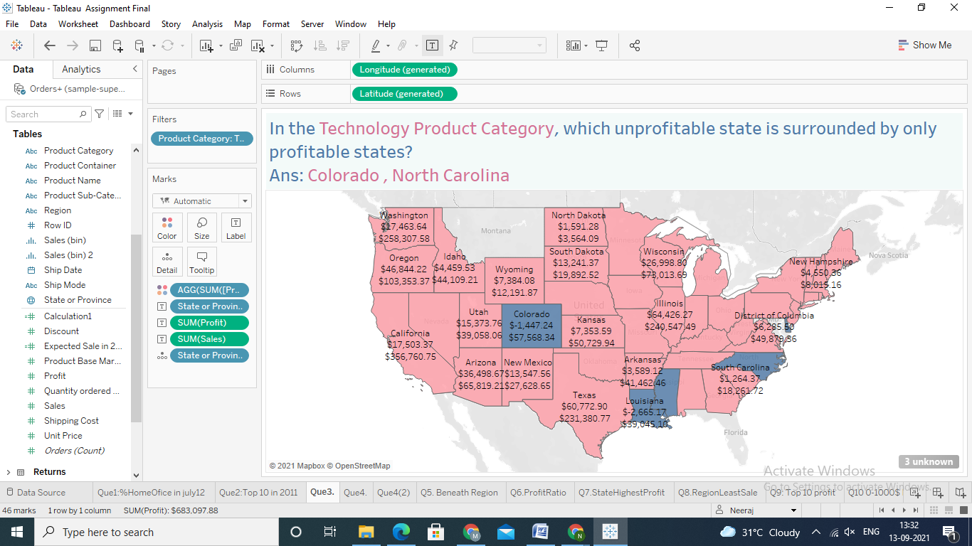

4. If 2013 Sales numbers were expected to increase by 50% in the following year, what would be the

total estimated sales for the Consumer Segment in2014?

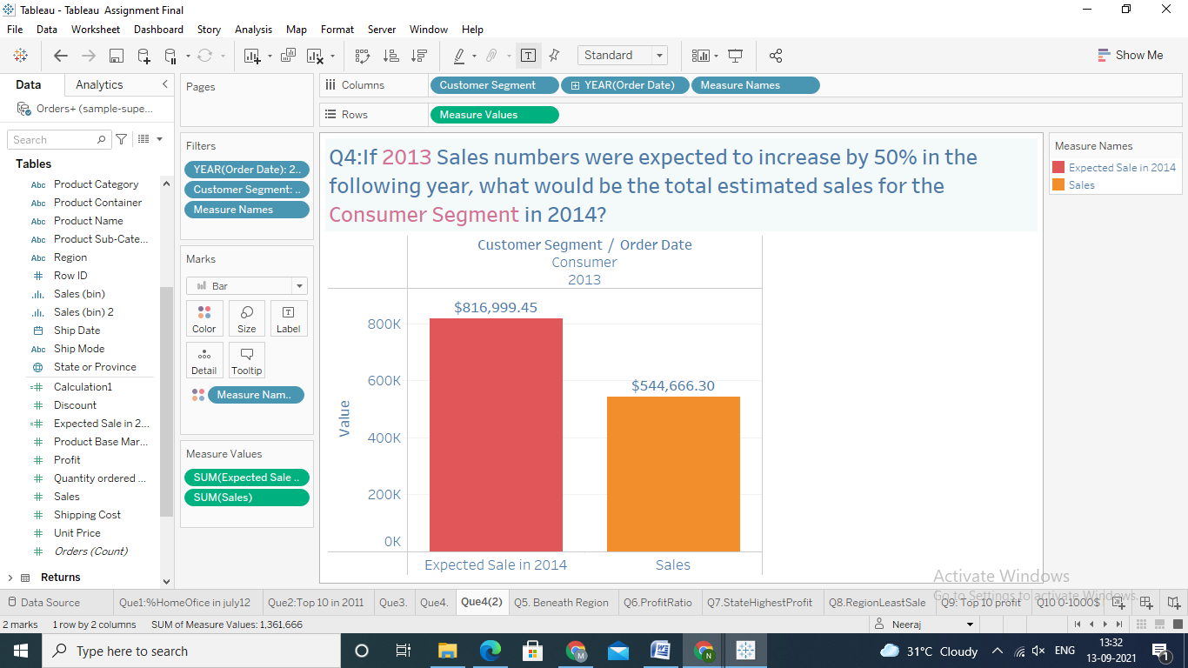

5. In which Region do all Product Categories fall beneath the overall average profit?

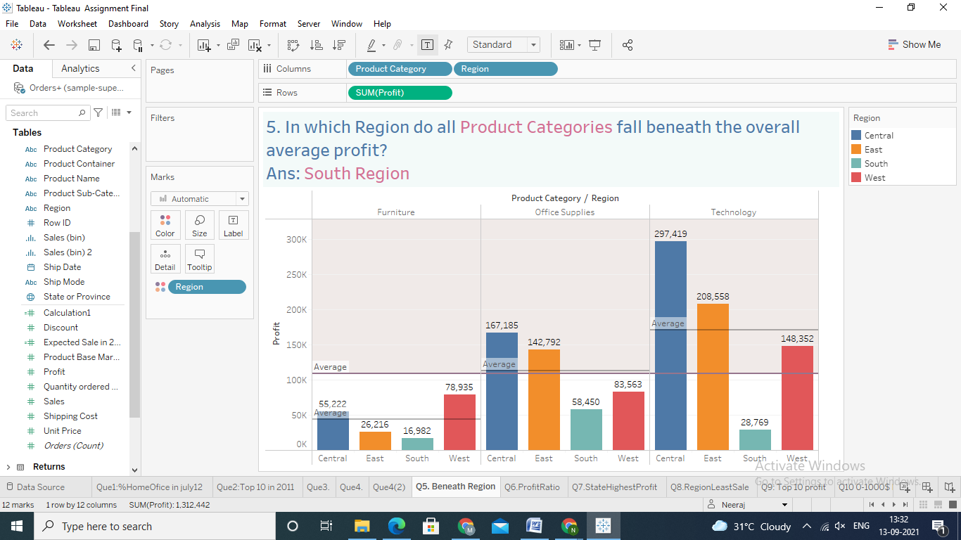

6. Find the customer with the lowest overall profit ratio. What is his/her profit ratio? (profit ratio is

profit over sales)

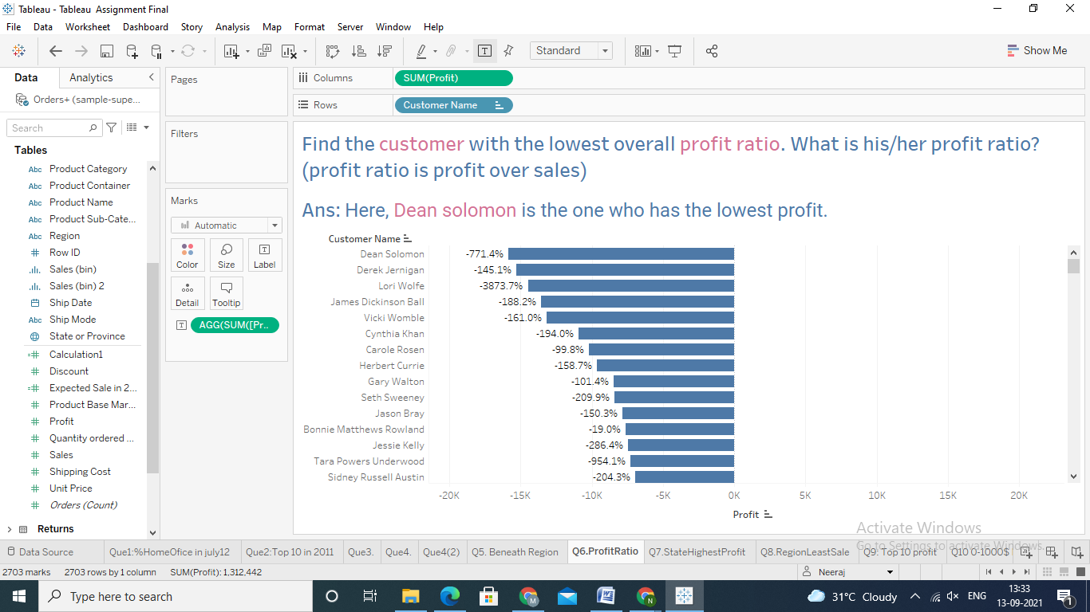

7. Determine which State in the Central Region has the highest profits?

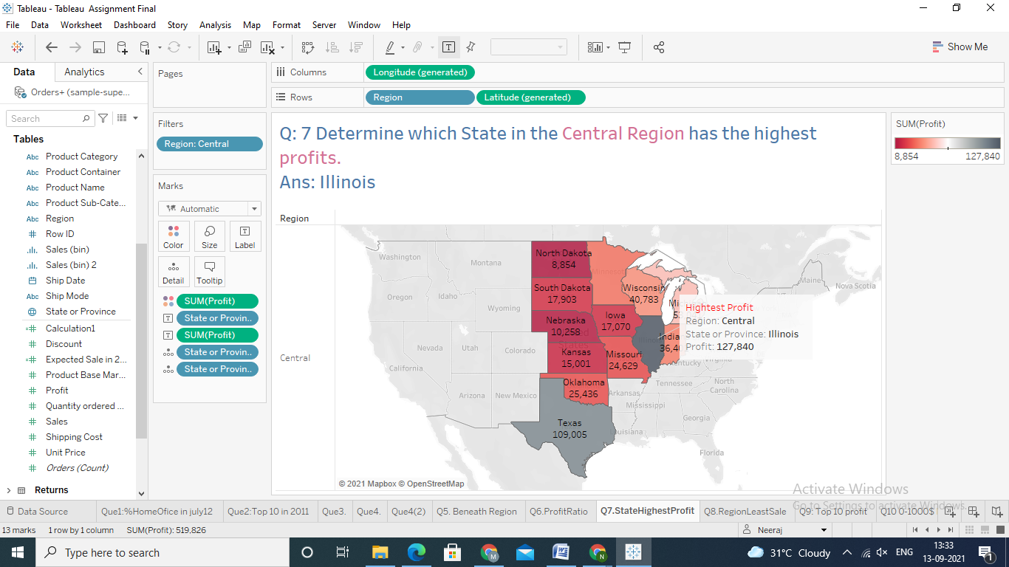

8. Which region has the least number of product sub-categories that are making a loss?

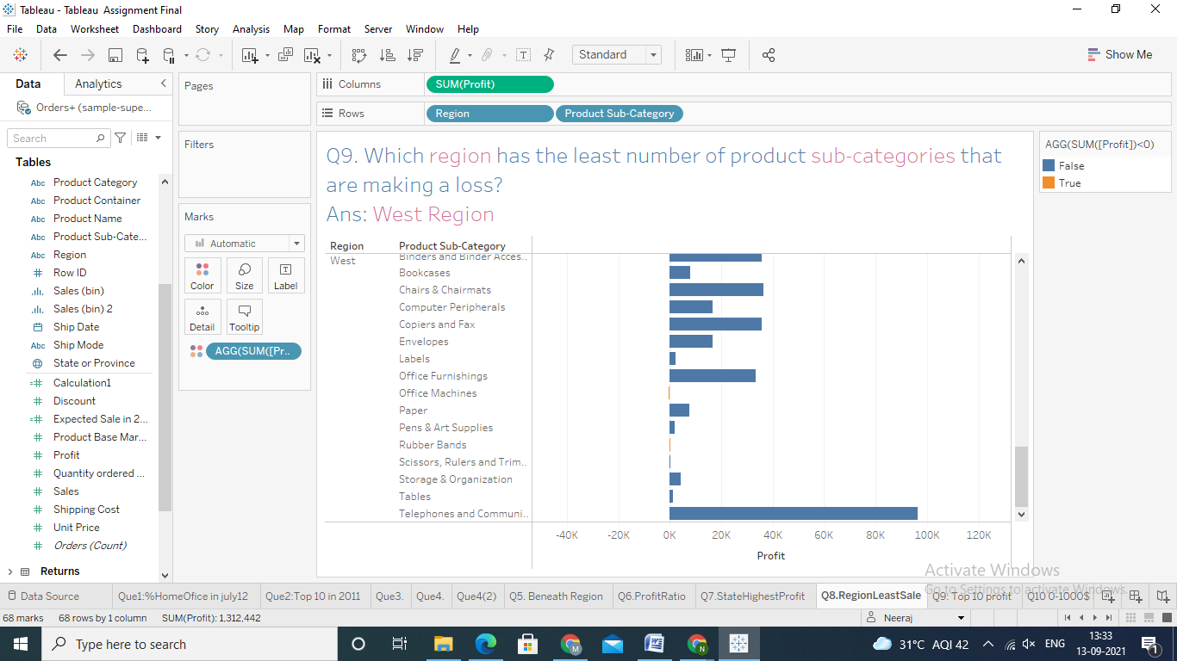

9. What percent of the total profit do the top 10 customers by Sales represent?

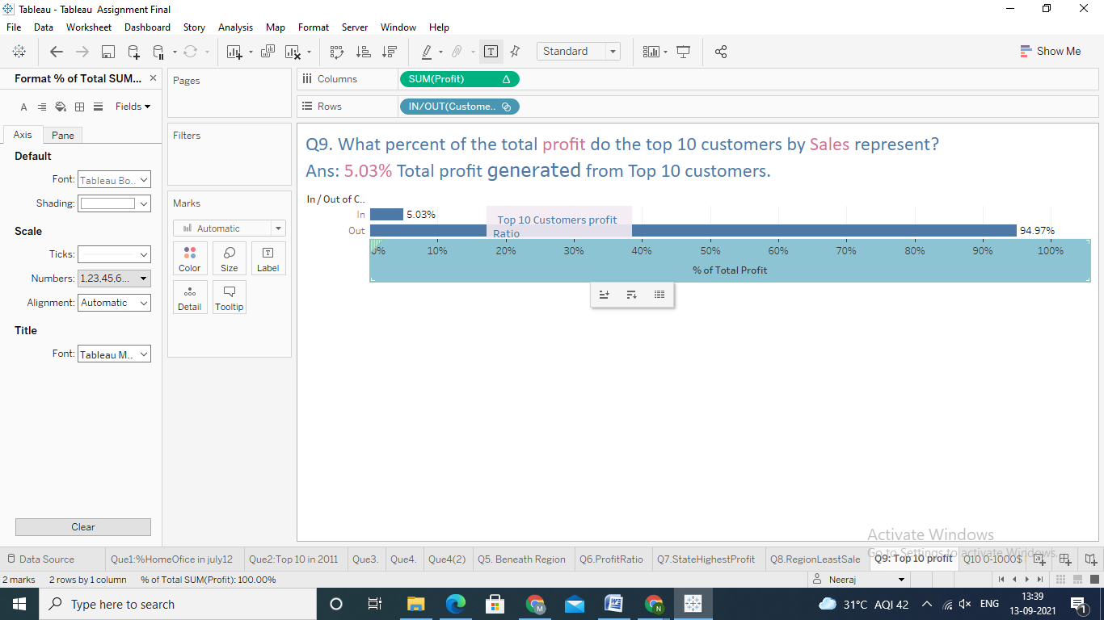

10. How many sales have been made within the range of 0-1000$? (Create a histogram showing

the number of Sales using Sales Bins of $1,000).

